Project Patona:

MoM as of Aug. 20, 2020

Action Items

1.) Stock on Hand pie chart to align on Stock on Hand as of the current period table

c/o Marco – Target completion Aug. 25, 2020

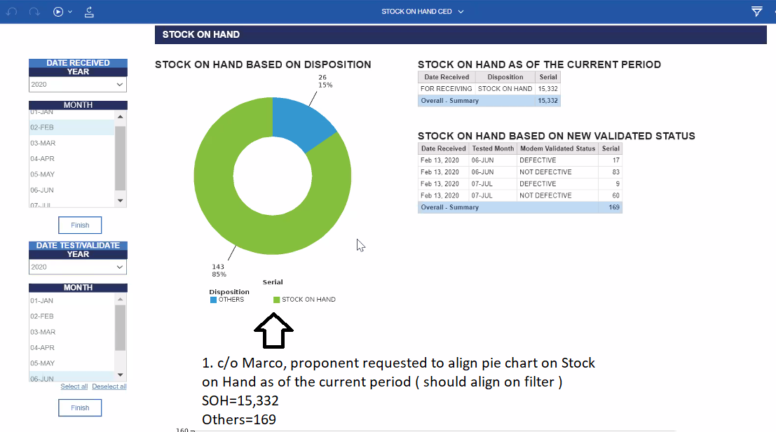

2. Marco to ensure modem validated status will align on filter - Target completion Aug. 25, 2020

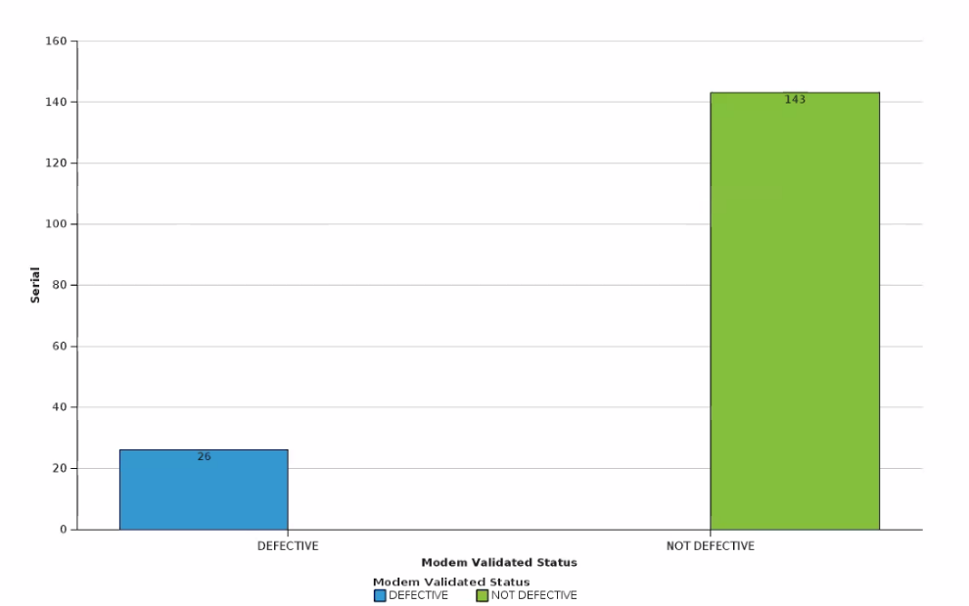

3. Defect Validation Status trend ( Repair Tickets ) - Nexus has an open ticket with IBM to cater the request ( enhanced the graph ensuring to display 12 months status tend )

4. Nexus to provide support on the following ( If IBM has no recommendation ) - Target completion Aug. 25, 2020

* Ensure there is space between each month ( per set of bar graph )
* Remove graph cylindrical figure
* Sample graph trend for 12 months

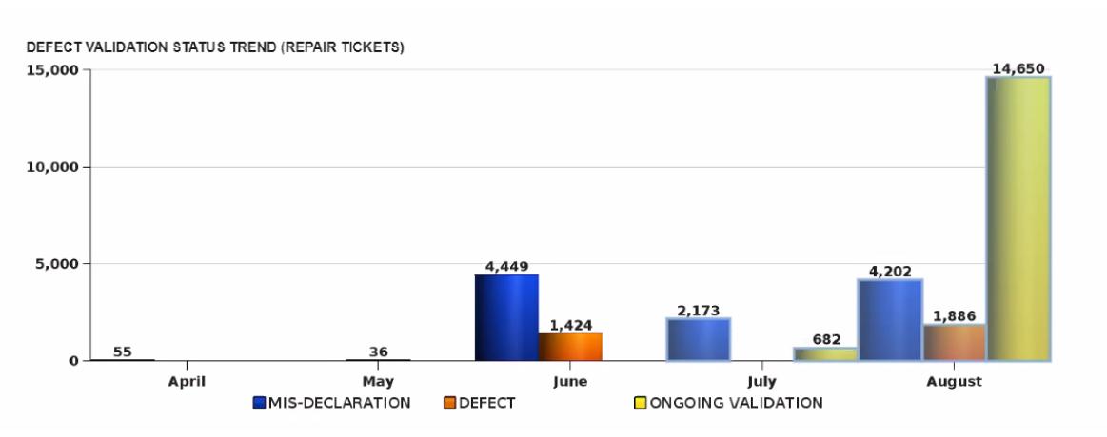

5. Sir Abe to ensure cascade will be made once again to Lemcon and Telcomtrix to ensure right format will be utilized during data loading

Attendance:



Agreement made:

Proponents team agreed to retain the following format:

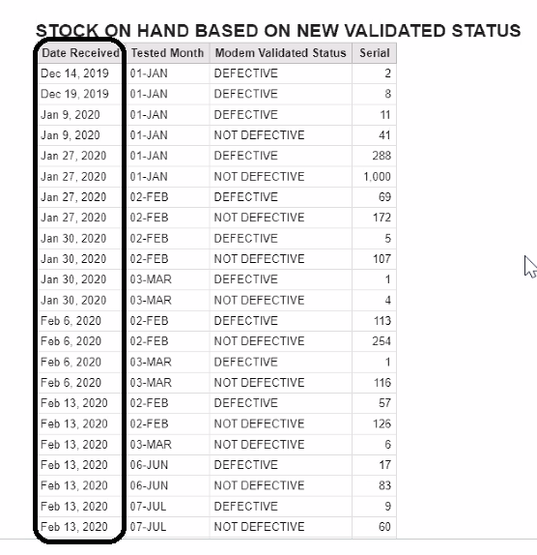

Thank you!

Regards,

Rey Ronquillo